

Emergency Contact List
v2.1
An Example Push Application for BlackBerry

Table of Contents
1.0 Overview 3
1.1 Application Structure 3
1.2 Customizing the Example 4
1.3 Why the Two Kinds of Push? 4
1.4 Reliable Push with PAP 5
2.0 ECL Service 7
2.1 Who should use this? 7
2.2 Installation Instructions 7
2.3 How to use this? 7
3.0 ECL Command Line 9
3.1 Who should use this? 9
3.2 Installation Instructions 9
3.3 How to use this? 9
4.0 ECL GUI 11
4.1 Who should use this? 11
4.2 Installation Instructions 11
4.3 How to use this? 11
5.0 WEB UI 14
5.1 Why should you use this? 14
5.2 Installation Instructions 14
5.3 How to use this? 14
6.0 Configuration 16
6.1 BESMgmt Settings 18
7.0 System Requirements 19
8.0 Known Issues 19

List of Figures:
Figure 1: Structure of ECL Application 3
Figure 2: Reliable Push Architecture 6
Figure 3: ECL User Interface 11
Figure 4: Expanded ECL User Interface 12
Figure 5: ECL WEB client 14

List of Tables:
Table 1: Settings.config 17
Table 2: BESMgmt settings.config 18

1.0 Overview

1.1 Application Structure
This document describes the Emergency Contact List Application written using .NET.

This Emergency Contact List (ECL) example pushes contact data in MS Excel, MS Access and MS SQL Server to BlackBerry handhelds by using push functionality.

This Application has been designed to demonstrate the different User Interfaces (UI) that can be used to perform the data push. There are 4 different interfaces that can be used depending on your need:
i) ECL Service Application - Makes a push at a regular interval to all the devices
ii) ECL Command Line application – Makes a push once to all the devices using the command prompt
iii) ECL GUI Application - Makes a push once to all the devices using the GUI
iv) ECL Web Application – Makes a push once to all the devices using the browser

All these interfaces depend on the ECLLogic.dll to process the inputs and perform the push.

ECLService - This is a windows service which pushes the ECL on a regular interval. It is configured using Settings.config | ECLConsole - This is a windows console application. It is run from a console and it is configured using Settings.Config | ECL_GUI - This is a windows GUI application. It is configured using the GUI. | ECL_WEB - This is a windows browser application. It uses configuration of web.config and the ones made on the browser.
ECLLogic.dll - This is the ECL Logic Engine and is used by all four applications to process the parameters and send push.
Figure 1: Structure of ECL Application

There are 2 types of push that can be performed using these Applications.

i) Browser Channel Push, where the server encodes the contact data in an HTML page and pushes that page to the BlackBerry Browser. When the browser receives a Channel Push, it stores the pushed content in its cache and adds an icon to the main ribbon that acts as a bookmark to that page. In this form, the program on the handheld is the BlackBerry browser, so there is no ECL-specific code that needs to be installed on the handheld.

ii) Client Catcher: Here, the server encodes the contact data into a non-standard format and sends that to a custom handheld application that must be installed on the user's BlackBerry. When this catcher receives a pushed message, it stores the encoded data locally using the BlackBerry persistence framework.

For installation, open the Application Loader file [setup\Device\ECLContactList.alx] with your BlackBerry desktop software and follow the procedure for installing that program on your cradled handheld. Once installed, the catcher is running in the background.

Alternatively, if using the simulator, open the workspace [soruce\Device\com\rim\application\genericview\ECLContactList.jdw] in the BlackBerry Java Development Environment and press F5 to launch the device simulator; make sure that the MDS simulator is running too.

1.2 Customizing the Example

There are two kinds of customizations that are easily made to this example: making it read a different spreadsheet/Database format and changing how the list gets displayed on the device.

To make this demo work with a different spreadsheet format, it is important to understand how the server program reads data from the Excel workbook. The server is "hard coded" to understand the arrangement of cells found in XYZ Company's spreadsheet/database table. It scans the worksheet from top to bottom, searching for rows that contain data in the first column but not in the second. Such rows are interpreted as group headings. Other rows are interpreted as people within the most recently started group. The data from all non-empty cells in a person's row become the line items that make up the person's record when it is displayed on the device.

When the server program is processing a person's row and encounters a non-empty cell, it applies the formatting rule for the appropriate column when generating that field's line item. Note that the headings' row in the spreadsheet is ignored. Thus, as long as the new format is similar enough to the old, you can adapt the server to read a differently formatted spreadsheet by adjusting these properties.

In order to read a drastically different format, it is necessary to change the server code. All the logic for parsing spreadsheets is in [DataReader.cs]. This component accesses the spreadsheet using the row/column interface provided by OLEDB. While the server issues SQL commands over OLEDB, it is not using a relational database paradigm; rather, it is using the scanning algorithm described above.

To customize the view on the device, please refer to the case study found under [source\device].

1.3 Why the Two Kinds of Push?

This example serves as an introduction to Push applications---those that proactively make corporate data available to BlackBerry handhelds. Once you understand this demo, you will have two new tools in your kit: browser-based push and custom client push. Each tool has its own merits.

Browser-based applications have the advantage that there is no client code to install and manage. There is also the simplicity of HTML for specifying user interfaces.

Custom clients, on the other hand, get direct control over data management. In the Browser Channel version of this ECL example, the BlackBerry Browser's caching mechanism is charged with the responsibility of maintaining the contact list on the device. But theoretically, the browser could release that page from cache at any time. Only a true persistence strategy (such as that used by the Custom Catcher version) can guarantee the offline availability of previously pushed data when it is needed.

1.4 Reliable Push with PAP

Push Access Protocol (PAP) allows push reliability, which entails device confirmation for a push. This functionality is only available with 4.0+.

PAP allows two types of acknowledgement from the device: Transport-Level and Application-Level. Transport-Level acknowledgement is a result of the device is receiving the data properly, where as Application-Level is a result that the particular application on the device has processed the data properly. All PAP pushes are stored in the BES database and therefore these additional functionalities are provided:

- Delivery After timestamp
- Delivery Before timestamp
- Query push status
- Cancel push
- Replace a push request
- Send to multiple users under one push-id

Using reliable push, the application server receives a confirmation from the MDS and the PAP listener receives the confirmation from the device. Figure 2 illustrates 6 steps that occur for a reliable push.

- Application server initiates a push
- BES confirms the parameters and matches the email address to the PIN.
- MDS sends the proper notification to the application server. Note: The application server no longer needs to be listening for any other notification.
- The MDS pushes the content to the Device.
- The device sends the proper notification back to the MDS
- MDS provides the notify listener with the device’s response

For a non reliable push steps 1-4 occur; hence “fire and forget” model. For more information on PAP please visit: http://www.wmlclub.com/docs/especwap2.0/WAP-247-PAP-20010429-a.pdf

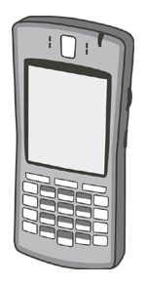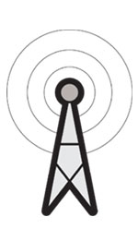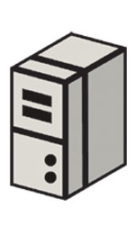
1
2
3
4
5
6
Mobile Data Service
Configuration DB
BlackBerry Enterprise Server
BlackBerry
Device
Wireless Network
Internet
Firewall
Push Application
Notify Listener
Figure 2: Reliable Push Architecture

PAP Installation:

- Make sure you have either IIS or Apache web server installed.
- Go to directory EmergencyContactList\Server\dotNET\setup\PAP and click on setup.exe
3. Make sure SQL server is installed. Run the pap.txt under a database.
4. Update the web.config with the proper database name, user ID and password; under the key “DataAddress.”

Note: PAP will is NOT available for ECL GUI, but is available for the other three.
2.0 ECL Service

2.1 Who should use this?
If you would like to make a push at a regular interval to all the devices then use this. This is a Windows Service.

2.2 Installation Instructions
- Make sure you have the .NET framework installed. If not then go get dotnetfx.exe and install it. This is the Microsoft .Net Runtime Redistributable Package and is required to be installed before the application. If you have it then go to Step 2.
- Go to directory EmergencyContactList\Server\dotNET\setup\service and click on setup.exe
The installation is complete.

2.3 How to use this?

This application reads all the values including the interval at which to make a push from Settings.config file located in project installation directory which should usually be
C:\Program Files\Research In Motion\Emergency Contact List Service
1) Open Settings.config – This is an XML file and all settings are in key and value pair. DO NOT MODIFY the KEY. You can change the value of the key to customize the service to your environment. For example: This is a sample property from the config file
<!-- Timer Interval=set to 10 min(600000ms)-->
<add key="servicepollinterval" value="600000" />
To change the value of the timer from 10 min to 30 min, change 600000 to 1800000. But NEVER modify the key i.e. “servicepollinterval”
Another Example is the column format, where ColumnFormat0 is the 1st column of your table or spreadsheet.
<!--The format of how each column's data gets displayed on the handheld; "%0" gets replaced with data.-->
<add key="ColumnFormat0" value="%0" />
<add key="ColumnFormat1" value="%0" />
<add key="ColumnFormat2" value="Office: %0" />
<add key="ColumnFormat3" value="Cell: %0" />
<add key="ColumnFormat4" value="Email: %0" />
<add key="ColumnFormat5" value="BlackBerry: pin:%0" />
<add key="ColumnFormat6" value="Prime Backup: %0" />
2) Once you have made all the settings, then save the file and go to
Start Menu->Settings->Control Panel->Administrative Tools->Services
3)In the Services Dialog, look for ECLService, right click on it select start. The service has now started running. To monitor the activities of the service check the .log file in the project installation directory. NOTE: Before you start the service make sure you have configured Settings.config, user.txt and your data file (.xls, .mdb or SQL database). Look at the Settings.config section for more information

In the project installation directory you will also see some sample files:
User.txt: Sample user information file
xyzlist.xls: Sample ECL in Excel
xyzlist.mdb: Sample ECL in Access
xyzlist.sql: Sample schema for MSSQL 2000
sampledata.txt: Sample data that can be exported in MSSQL

NOTE: Make sure to modify Settings.config file in the Application folder to set all the properties correctly. You cannot make a successful push until this file has the correct properties. The service should be restarted for changes to take place.
Also when using the catcher option make sure you have installed the catcher application on your device or simulator.

3.0 ECL Command Line

3.1 Who should use this?
If you would like to make a one time push and like using the Command Line

3.2 Installation Instructions
- Make sure you have the .NET framework installed. If not then go get dotnetfx.exe and install it. This is the Microsoft .Net Runtime Redistributable Package and is required to be installed before the application. If you have it then go to Step 2.
- Go to directory EmergencyContactList\Server\dotNET\setup\cmd and click on setup.exe
The installation is complete.

3.3 How to use this?

This application reads all the values including the interval at which to make a push from Settings.config file located in project installation directory
C:\Program Files\Research In Motion\Emergency Contact List Command Line
1) Open Settings.config – This is an XML file and all settings are in key and value pair. DO NOT MODIFY the KEY. You can change the value of the key to customize the service to your environment. For example: This is a sample property from the config file
<!-- Timer Interval=set to 10 min(600000ms)-->
<add key="servicepollinterval" value="600000" />
To change the value of the timer from 10 min to 30 min, change 600000 to 1800000. But NEVER modify the key i.e. “servicepollinterval”
Another Example is the column format, where ColumnFormat0 is the 1st column of your table or spreadsheet.
<!--The format of how each column's data gets displayed on the handheld; "%0" gets replaced with data.-->
<add key="ColumnFormat0" value="%0" />
<add key="ColumnFormat1" value="%0" />
<add key="ColumnFormat2" value="Office: %0" />
<add key="ColumnFormat3" value="Cell: %0" />
<add key="ColumnFormat4" value="Email: %0" />
<add key="ColumnFormat5" value="BlackBerry: pin:%0" />
<add key="ColumnFormat6" value="Prime Backup: %0" />

2) Once you have made all the settings, then save the file and open a command prompt
NOTE: Before you start the command prompt make sure you have configured Settings.config, user.txt and your data file (.xls, .mdb or SQL database). Look at the Settings.config section for more information
3) Go to C:\Program Files\Research In Motion\Emergency Contact List Command Line folder
4) To push to browser type
>ECLCommandLine channel
To push to catcher
>ECLCommandLine catcher

To monitor the activities of the application check the .log file in the project installation directory.

In the project installation directory you will also see some sample files:
User.txt: Sample user information file
xyzlist.xls: Sample ECL in Excel
xyzlist.mdb: Sample ECL in Access
xyzlist.sql: Sample schema for MSSQL 2000
sampledata.txt: Sample data that can be exported in MSSQL

NOTE: Make sure to modify Settings.config file in the Application folder to set all the properties correctly. You cannot make a successful push until this file has the correct properties.
Also when using the catcher option, make sure you have installed the catcher application on your device or simulator.

4.0 ECL GUI

4.1 Who should use this?
If you would like to make a one time push and prefer GUI over Command Line.

4.2 Installation Instructions
- Make sure you have the .NET framework installed. If not then go get dotnetfx.exe and install it. This is the Microsoft .Net Runtime Redistributable Package and is required to be installed before the application. If you have it then go to Step 2.
- Go to directory EmergencyContactList\Server\dotNET\setup\gui and click on setup.exe
The installation is complete.

4.3 How to use this?

Go to Start Menu->Program File->Research In Motion-> Emergency Contact List and click on Emergency Contact List. The Application window as seen in Figure 2 below will be launched.

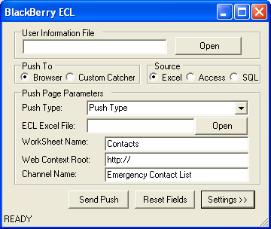
Figure 3: ECL User Interface

If you click on the Settings >> button you will see the screen in Figure 3 below.

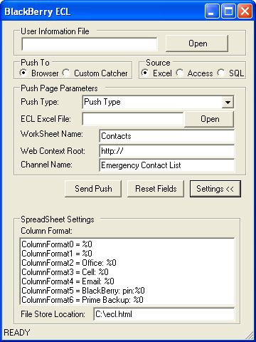
Figure 4: Expanded ECL User Interface

The following is the description of the fields in the User Interface:

- User Information File: The file that stores BESHOST BESPORT USER_EMAIL. A sample file "user.txt" is given
- Push To: Select the Push Destination (Browser or Custom Catcher)
Note: When using the catcher option, make sure you have installed the catcher application on your device or simulator.

- Select Push Type: Browser-Channel or Browser-Channel-Delete.
Note: For Browser-Channel-Delete you need to have the same settings that were at the time Channel Push was made in order to delete the channel successfully

- Source: The Source where the data is to be extracted from. It can be an Excel Sheet (.xls), Access Database (.mdb) or MS SQL Database file.
If Excel is selected: -
ECL Excel File: The name of Excel File
Worksheet Name: The name of Worksheet in the Excel file from which to extract data

If Access is selected: -
ECL Access File: The name of Access File
Table Name: The name of Table in the Access file from which to extract data
If MSSQL is selected: -
Server Name: The name of Excel File
Worksheet Name: The name of Worksheet in the Excel file from which to extract data

- WebContextRoot: The location where the ecl_read_icon.gif and ecl_unread_icon.gif is stored.
Example: http://www.myhost.com/ECL
- Channel Name: The Name to Appear on BB, used when doing a browser push.
- “Send Push” Button: Used to send push
- “Settings >>” Button: Use to view the optional settings
- Column Format: Used to set the column format you would like to see on your BB. ColumnFormat0 is the 1st column; ColumnFormat1 is the 2nd column of your table or spreadsheet and so on.“%0" gets replaced with data.
- File Store Location: Optionally if you would like to store the generated HTML file on you computer before pushing

To monitor the activities of the application check the .log file in the project installation directory.

In the project installation directory you will also see some sample files:
User.txt: Sample user information file
xyzlist.xls: Sample ECL in Excel
xyzlist.mdb: Sample ECL in Access
xyzlist.sql: Sample schema for MSSQL 2000
sampledata.txt: Sample data that can be exported in MSSQL

5.0 WEB UI

5.1 Why should you use this?
If you would like to use a UI that offers all PAP functionality and can be installed on a server to be readily available.

5.2 Installation Instructions
- Make sure you have either IIS or Apache web server installed.
- Go to directory EmergencyContactList\Server\dotNET\setup\WEB and click on setup.exe
- Once installed, edit the web.config, found in the directory of WEB installation, and please refer to Section 6.0 Configuration for more detail.
The installation is complete.

5.3 How to use this?

From your browser, browse to the location of this installation, by default it should be http://localhost/ECL. Figure 3, below, should be launched.

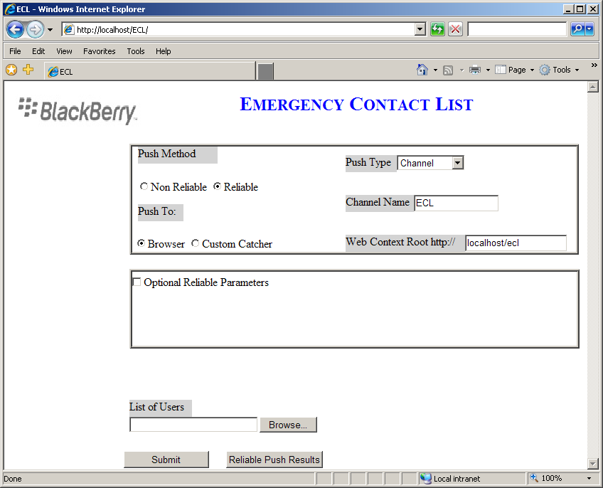
Figure 5: ECL WEB client

The following is the description of the fields in the User Interface:

- Push Method: Reliable push uses PAP as underlining push, Non Reliable uses pre 4.0 push
- Push To: Select the Push Destination (Browser or Custom Catcher.)
Note: When using the catcher option, make sure you have installed the catcher application on your device or simulator.

- Select Push Type: Browser-Channel or Browser-Channel-Delete.
Note: For Browser-Channel-Delete you need to have the same settings that were at the time Channel Push was made in order to delete the channel successfully.

- WebContextRoot: The location where the ecl_read_icon.gif and ecl_unread_icon.gif is stored. Example: http://www.myhost.com/ECL
- Channel Name: The Name to Appear on BB, used when doing a browser push
- List of Users: The file that stores BESHOST BESPORT USER_EMAIL. A sample file "user.txt" is given
- Submit: Sends the push
- Reliable Push Results: Queries the PAP database and displays reliable pushes made so far

Optional Reliable Parameters are only available if Reliable push is selected.

- Push ID: Define a unique Push ID. One ID cannot be used to represent two different pushes. (One is randomly generated if one is not provided.)
- Delivery Before Timestamp: If provided, the push has to be delivered successfully before the provided time, else the push gets dropped
- Delivery After Timestamp: If provided, the push can be only delivered after the provided time
Note: For both fields please follow the syntax provided.

- Priority: Quality of Service attributes, by default it’s high. Implementation for this attribute can be customized
- Delivery Method: Quality of Service attribute, “confirmed” indicates delivery confirmation is needs to be sent to the push initiator engine

To monitor the activities of the application check the .log file in the log4net directory specified in web.config.

In the project installation directory you will also see some sample files:
User.txt: Sample user information file
xyzlist.xls: Sample ECL in Excel
xyzlist.mdb: Sample ECL in Access
xyzlist.sql: Sample schema for MSSQL 2000
sampledata.txt: Sample data that can be exported in MSSQL

6.0 Configuration

This file is used to make settings for the Command Line and service application. This section explains the key-value pairs that are used in the Settings.config file.

Key | Value | Description
RecipientEmails | C:\Documents and Settings\user\My Documents\Visual StudioProjects\ECL\user.txt | User Information File: The file that stores BESHOST BESPORT USER_EMAIL to which the push will be made. A sample file "user.txt" is given
ConnectionType | Access or Excel or MSSQL | The Source where the data is to be extracted from. It can be an Excel Sheet (.xls), Access Database (.mdb) or MS SQL Database file.
FileServerName | C:\Documents and Settings\user\My Documents\Visual Studio Projects\ECL\xyzlist.mdb  Or MYSERVER | If Excel is selected in ConnectionType: The name and location of Excel File.  If MSSQL is selected in ConnectionType: The name of MSSQL server. Example: value="MYSERVER"  If Access is selected in ConnectionType: The name and location of Access File
Sheet_Table_Name | Contacts | This field is used to specify the Excel Sheet Name/Database Table Name. If Excel is selected in ConnectionType: The name of Worksheet in the Excel file from which to extract data  If MSSQL is selected in ConnectionType: The name of server from which to extract data  If Access is selected in ConnectionType: The name of Table in the Access file from which to extract data
Database | ECL | THIS SHOULD ONLY BE USED IF CONNECTION TYPE IS MSSQL  If MSSQL is selected in ConnectionType: The name of database from which to extract data
WebContextRoot | http://localhost/ECL | URL prefix that identifies where the app's web resources are located. The device's browser may attempt to fetch any of the following:  - [WebContextRoot]/ecl_unread_icon.gif  - [WebContextRoot]/ecl_read_icon.gif  - [WebContextRoot]/ecl.html  The .gif files are in ECLv2.1/Server/content folder
ChannelName | Emergency Contact List | Title of the channel, i.e. what appears on the ribbon
StoreLocation | C:\Inetpub\wwwroot\ECL\ecl.html | Location at which to save the generated html page that the ECL server app builds by reading the spreadsheet. If a valid location is specified, then the exact content that gets pushed to devices is saved there. If the parameter is omitted or if it specifies an invalid location, the generated page won't be displayed, but all the pushes will be attempted anyway.

PushType | 0 or 1 | Push Type  0=Browser Channel Push  1=Browser Channel Delete
ColumnFormat0 | %0 | The format of how each column's data gets displayed on the handheld; "%0" gets replaced with data
ColumnFormat1 | %0
ColumnFormat2 | Office: %0
ColumnFormat3 | Cell: %0
ColumnFormat4 | Email: %0
ColumnFormat5 | BlackBerry: pin:%0
ColumnFormat6 | Prime Backup: %0
Service Only Settings
servicepollinterval | 3600000 | Timer Interval=set to 1 hr
PushTo | Channel | Push To: Channel or Catcher
Reliable Settings
PushMethod | NONPAP | Can be either PAP or NONPAP. Indicates which push methodology to use
NotifyURL | "http://localhost/ECL/PAPListener.aspx" | Location of where PAP is installed
PAPAddress | c:\inetpub\wwwroot\PAP\pap.txt | Location of pap.txt, which contains the PAP definition that is required for reliable push. Make sure the directory is browseable.
PushID | "" | A value will be generated if one is not supplied
BeforeTimestamp | YYYY-MM-DD:hh-mm-ss | Deliver prior to the specified time. YYYY-MM-DD:hh-mm-ss or valid value in this format
AfterTimestamp | YYYY-MM-DD:hh-mm-ss | Deliver after to the specified time. YYYY-MM-DD:hh-mm-ss or valid value in this format
Priority | high | Push priority relative to other requests. high, medium, low, default is high
Delivery | unconfirmed | Confirmed indicates MDS needs to respond to the push initiator, default is unconfirmed.
Web.config Only Setting
LogPropertyFile | c:\inetpub\wwwroot\ECL\log4net.xml | Logging control file, the directory must be shared
Table 1: Settings.config

6.1 BESMgmt Settings

There have been requests for BES 4.0 users to make use of the BES database for recipient and/or contact information. These settings support the use of the BES 4.0 database for recipient and contact information.
This file is used to make settings for the Command Line and service application. This section explains the key-value pairs that are used in the Settings.config file.
Key | Value | Description
BESMgmt | true | Used to activate use of BES database for recipient/contact information.
BESMgmtServer | machinename | Override File_Server_Name
BESMgmtContact | BESMgmt  or  Sheet_Table_Name value | This controls using BES database for contacts or the Sheet_Table_Name value for non BES database.
BesMgmtUsers | BESMgmt  or  Recipient_Emails value | This controls using BES database for recipients or the Recipient_Emails value for non BES database
BESMgmtConn | Provider=SQLOLEDB;server=gsiefried-lt;uid=sa;password=sa;database=besmgmt40  Or  Provider=SQLOLEDB;Server=servername;Database=dbname;Trusted_Connection=Yes | Used to provide a different connection string for the SQLServer.  The first uses ‘uid/password’ for testing.  The second uses ‘Trusted_Connection’ for production.
BESColumnNum | 4 | Used for the data format.
BESGroupName | Contacts | A value used in the custom Java application to provide a heading to the contact information. Any literal of your choosing can be used.
ColumnFormat0 | %0 | The format of how each column's data gets displayed on the handheld; "%0" gets replaced with data
ColumnFormat1 | Email: %0
ColumnFormat2 | Cell: %0
ColumnFormat3 | Pin: %0
Table 2: BESMgmt settings.config

7.0 System Requirements

The example was tested in the following environment.

1. Microsoft(R) Excel 2000 with accompanying OLEDB driver

2. Microsoft(R) Access 2000 with accompanying OLEDB driver

3. Microsoft(R) SQL Server 2000 with accompanying OLEDB driver

4. Microsoft .NET Framework 1.1

5. MDAC 2.8

8.0 Known Issues

- The column format for the WEB UI is hardcoded in “ECL.aspx”
- In “datastore.cs” part of PAP installer, the table name “PAP” is hardcoded
- Currently there is no session management for WEB UI

